Setting Up Application Environment Install IBM Cloud CLI

|  |  |
| --- | --- |
| **Date** | **10-11-2022** |
| **Team ID** | **PNT2022TMID50712** |
| **Project Name** | **Smart Fashion Recommender Application** |
| **Team Members:** | **Kavitha A, Kavitha V, Navina N** |

# Step 1:

Follow and do the step given in this page one by one

[***https://cloud.ibm.com/docs/cli/reference/ibmcloud_cli/get_started.html#getting-started***](https://cloud.ibm.com/docs/cli/reference/ibmcloud_cli/get_started.html#getting-started)

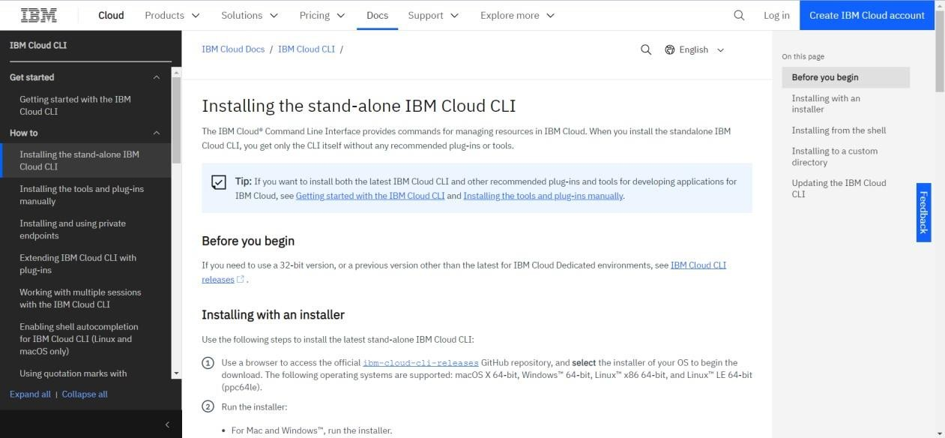

# Step 2:

Download Setup file from the link [***https://github.com/IBM-Cloud/ibm-cloud-cli-***](https://github.com/IBM-Cloud/ibm-cloud-cli-release/releases/)[***release/releases/***](https://github.com/IBM-Cloud/ibm-cloud-cli-release/releases/)

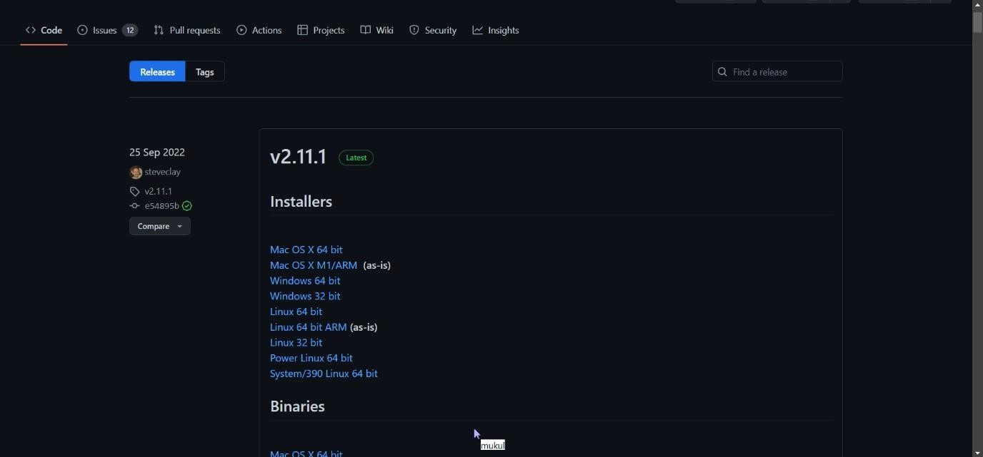

# Step 3:

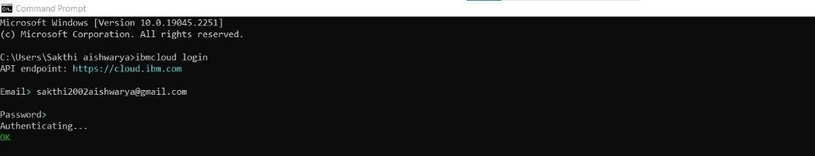Run the setup file

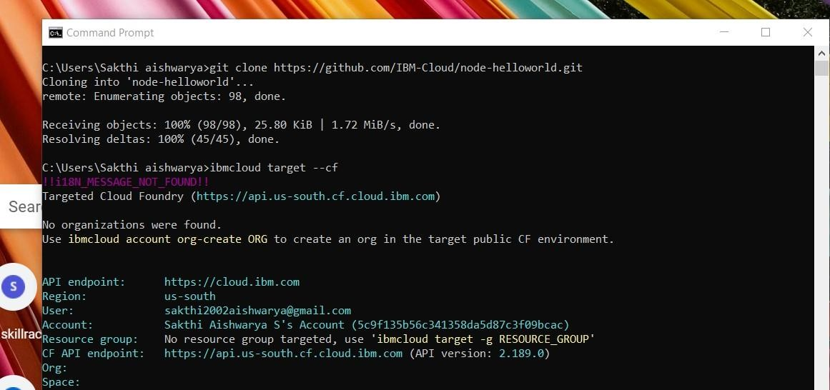

Step 4: Check for updates and version in cmd

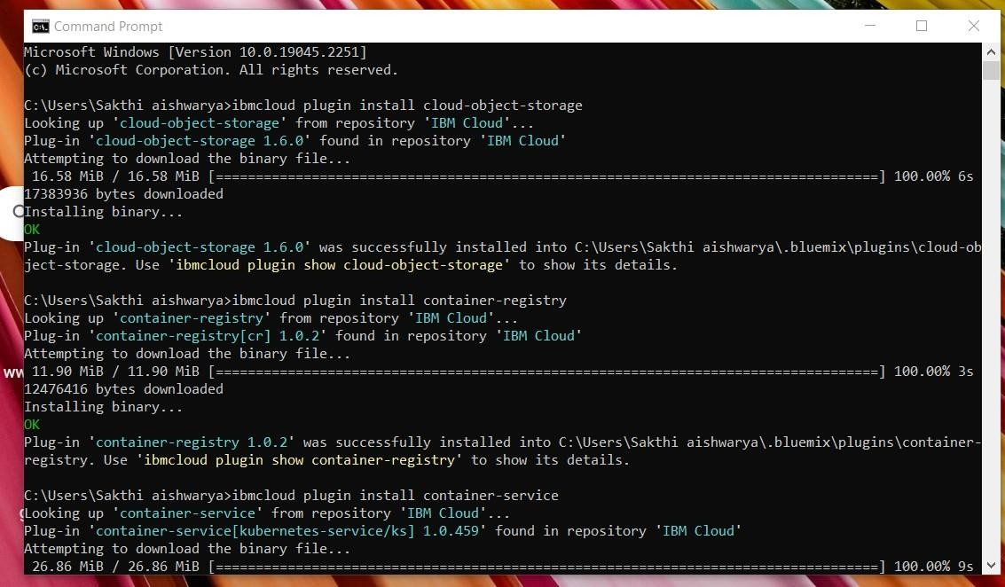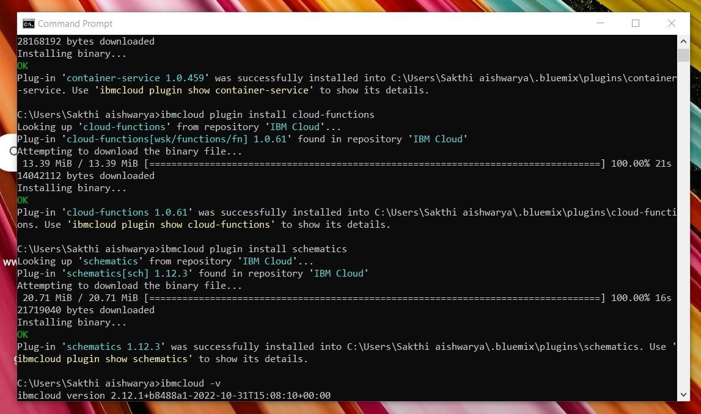

Step 5: Run all the command one by one in cmd

[***https://cloud.ibm.com/docs/containers?topic=containers***](https://cloud.ibm.com/docs/containers?topic=containers)[***-cs_cli_install***](https://cloud.ibm.com/docs/containers?topic=containers-cs_cli_install)

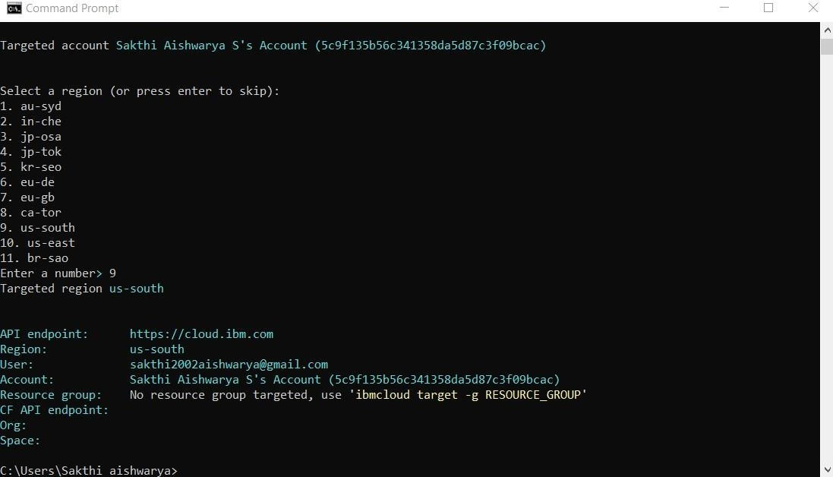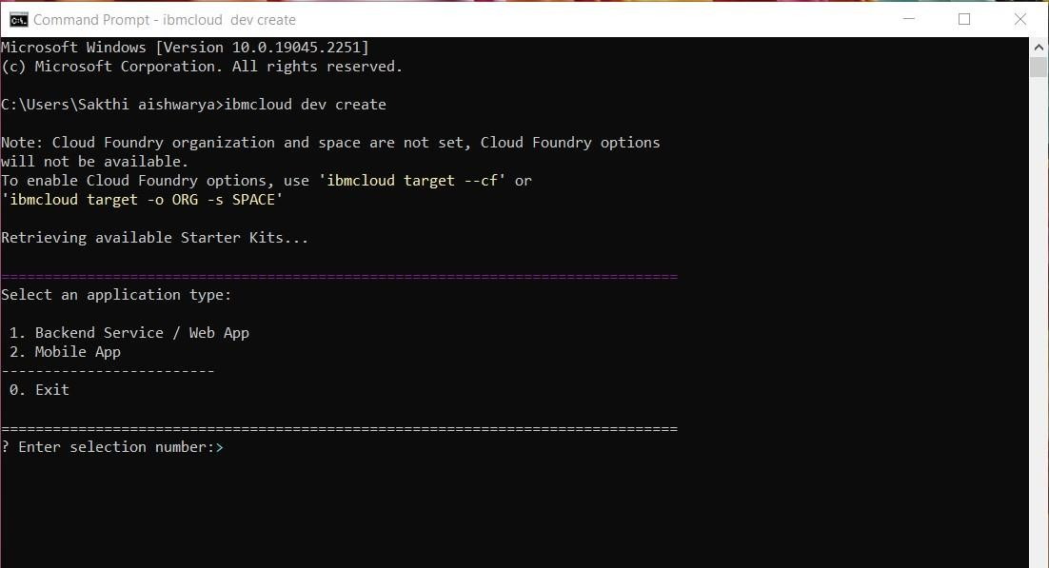

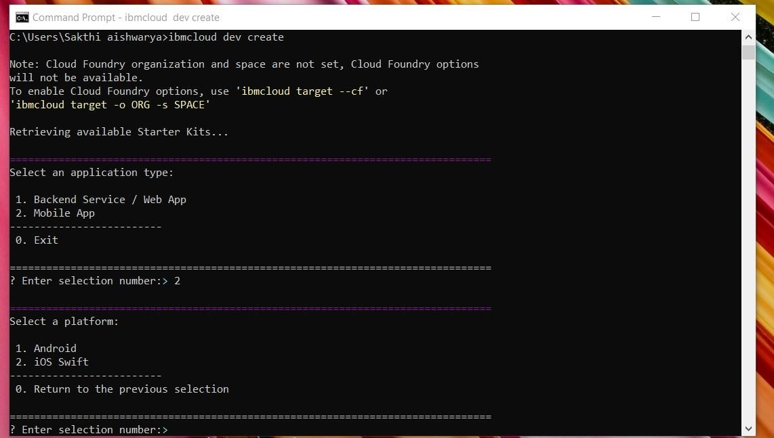

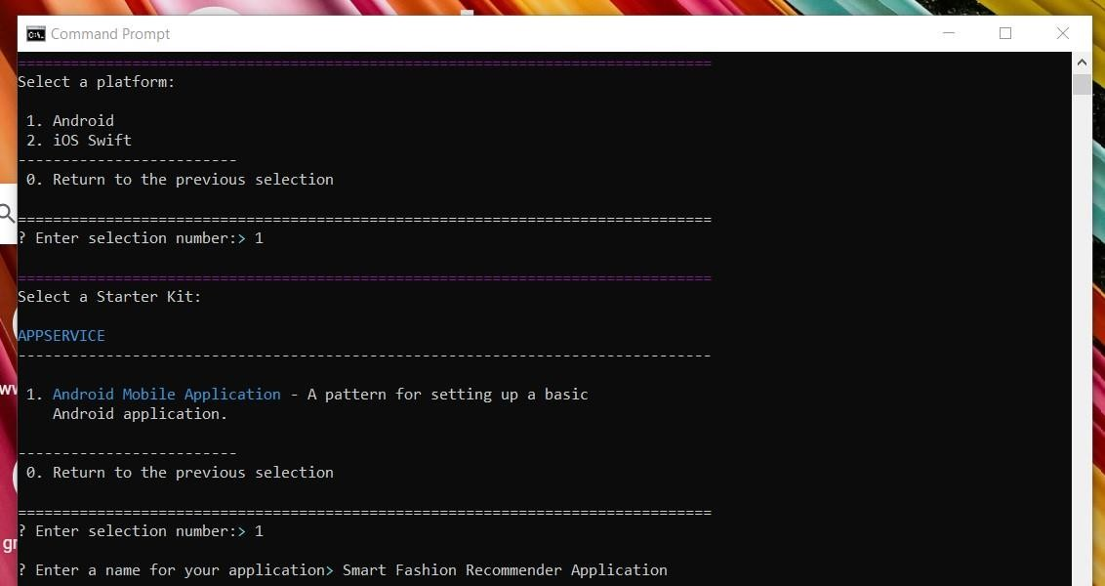

# Step 6:

Finally, the process of installation of IBM Cloud CLI is Completed.